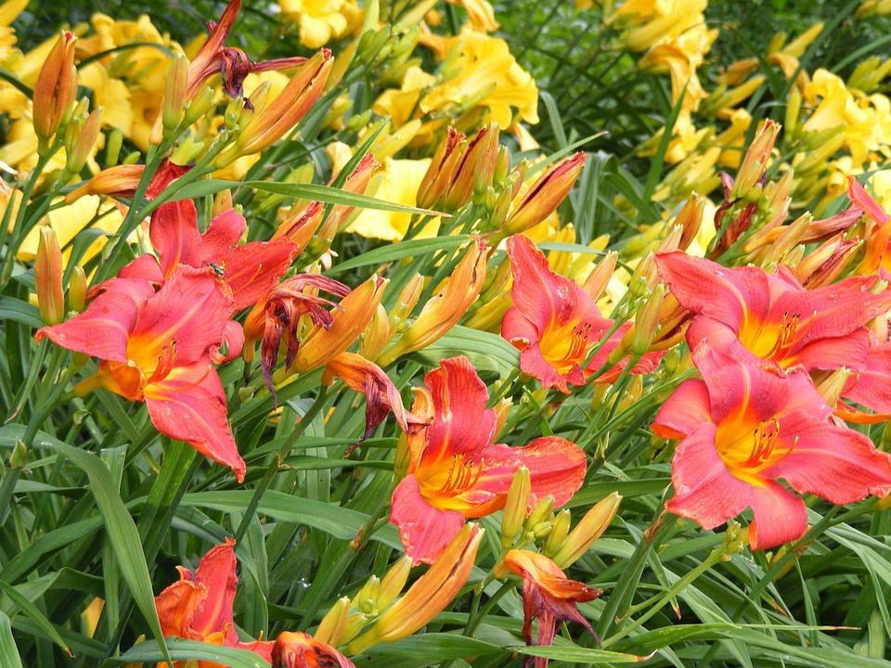

OHIO STATE UNIVERSITY EXTENSION

Daylily Show
Fayette County Master Gardener Volunteers
- First, Second, Third place cash prizes
- Section awards
- Best of Show: Horticulture Specimen
- Best of Show: Artistic Design
- Best of Show: Sweepstakes
- Guidelines and Policies at www.fayette.osu.edu
- One-day show open to everyone
- Vases provided for specimen classes

Horticulture and Design Classes
Not an OAGC sanctioned show.
Contact: Sara Creamer: 740-335-1150 or creamer.70@osu.edu

Saturday
July 9, 2022

Location: Agricultural Service Center
1415 US Rte. 22 SW
Washington C. H., Ohio 43160
Parking is free

Check in Begins at 8:00 am
Entries in place by 12:00 pm
Cost:
$1.00 per specimen
$3.00 per design

Judging: Begins at 1:00 pm Open to the public
And exhibitors

FAYETTE COUNTY

CFAES provides research and related educational programs to clientele on a nondiscriminatory basis. For more information, visit cfaesdiversity.osu.edu. For an accessible format of this publication, visit cfaes.osu.edu/accessibility.

