Using 4-HOnline

Ohio 4-H uses the 4-H Online system to manage all aspects of the 4-H program, including membership, events, projects, activities and communications. All youth and adults who participate in Ohio 4-H have a 4-H online profile.

Creating your 4-H online enrollment is easy and only takes a few minutes. 4-H online profiles are family-based, which means every family has a “master” profile for each family involved in Ohio 4-H. A family profile may contain both youth and adults:

Youth family members (ages 5-18 as of January 1)
  - Eligibility for Cloverbud participation begins when a child is age 5 and enrolled in kindergarten.
  - Eligibility for Club Member participation begins when a child is age 8 and in third grade. Any youth age 9 or above is eligible for project membership, regardless of grade level.
Adult family members (ages 18 and older)
  - Adults who have been screened and certified as Ohio 4-H Volunteers can re-enroll
  - Adults who want to become certified Ohio 4-H Volunteers complete a volunteer application, then create a 4-H online profile as part of their first time enrollment.

Not every Family profile will contain all the above listed types of members. Some profiles may contain only youth members, while others will have only adults. Some profiles will have both. Once a family profile is created, it will exist for as long as members of that profile are involved in the 4-H program. New members may be added to the family profile at any time and members who are no longer involved in 4-H may be archived.

If someone in your family was involved in Ohio 4-H from 2015-Sept 2020, you already have a family profile in 4-H online.

To Access your EXISTING family profile
OR
to create a NEW family profile, visit:
oh.4honline.com

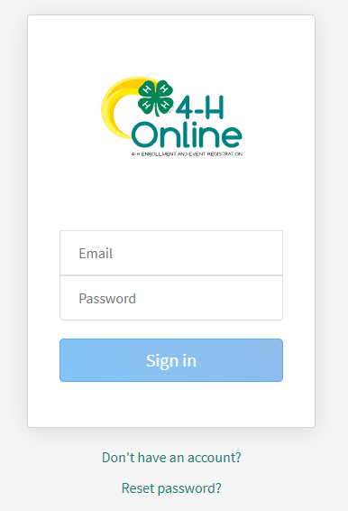
New 4-H Family Enrollment Guide

This guide will help you enroll for the first time in
Ohio 4-H.

Step 1: Visit: oh.4honline.com
- Mozilla Firefox and Google Chrome are the recommended browsers. Please do not use Internet Explorer.
- Select the option “Don’t have an account?”
- Select Ohio as your state and then “Ohio 4-H Youth Development”
- Select your county from the drop-down menu.
- Enter an email address, phone number and create a password
  - Note: The email address that you use will be used by all members of your family to log into 4-HOnline in the future.
- Enter your address, city, state and postal code.

Step 2: Build Your Member Profile
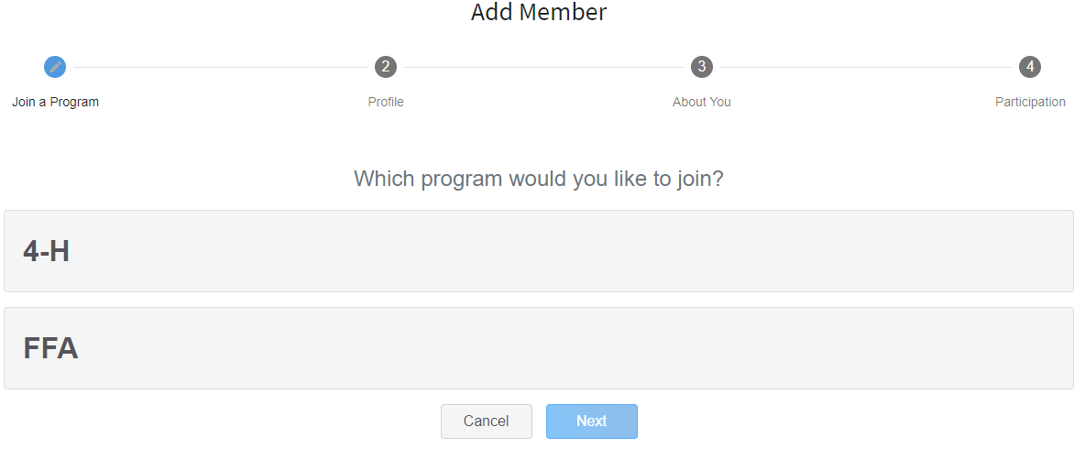
- Begin building the first member’s profile by choosing “add new member” and selecting “4-H” as the program you would like to join.

Select “Next” and continue through the rest of the questions, entering all of the required member information including name and birthdate. Select the option “I want to join 4-H as a new or returning member.” Then select “Finish”.

Step 3: Select Your Club(s)
- Select your 4-H Club(s) for this year by choosing the “Select Club” button.
- Verify that the county is correct at the top of the pop-up window and select the club(s) by selecting “Add” next to the club name.
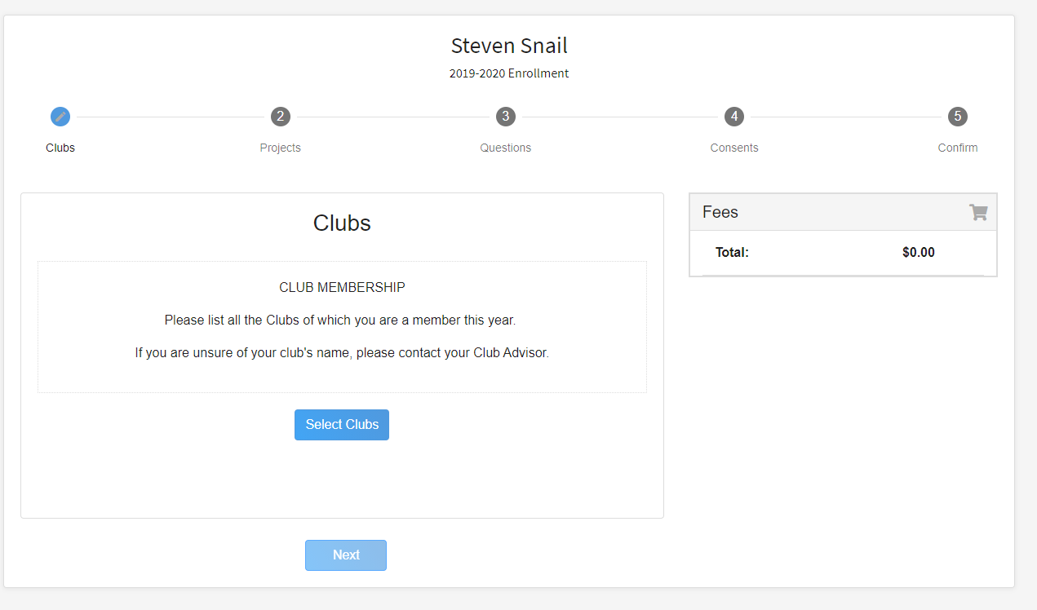
Step 4: Select Your Project(s) Select your 4-H projects(s) for this year by choosing the “Select Projects” button. Then select the projects from the list by clicking the “Add” button next to the project name.
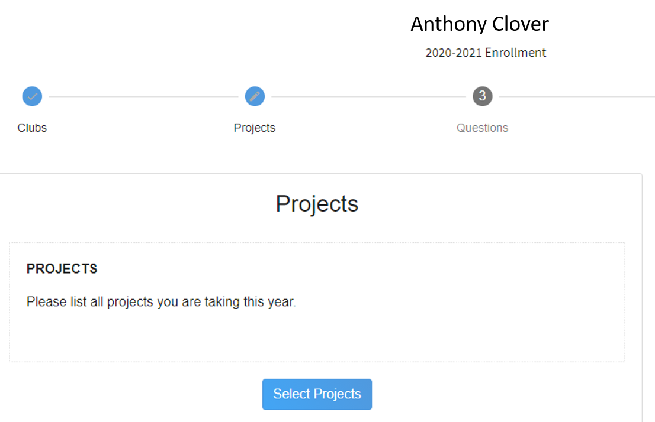

- Select all of the projects for this year before submitting your enrollment. If you need to make changes to your projects after submitting your enrollment, you will have to contact the Extension office to request a change.
- If you are enrolling in projects for more than one club, you will want to verify that you have selected the correct club at the top of the project pop-up window.
- If you select a horse project, a shooting sports project, or a dog project, you will be automatically prompted to electronically sign the appropriate project consents for those projects. Type your names in the boxes to affirm your agreement.
- Cloverbud members should select project number 710, Cloverbud Activities.

Step 5: Continue Enrollment Questions
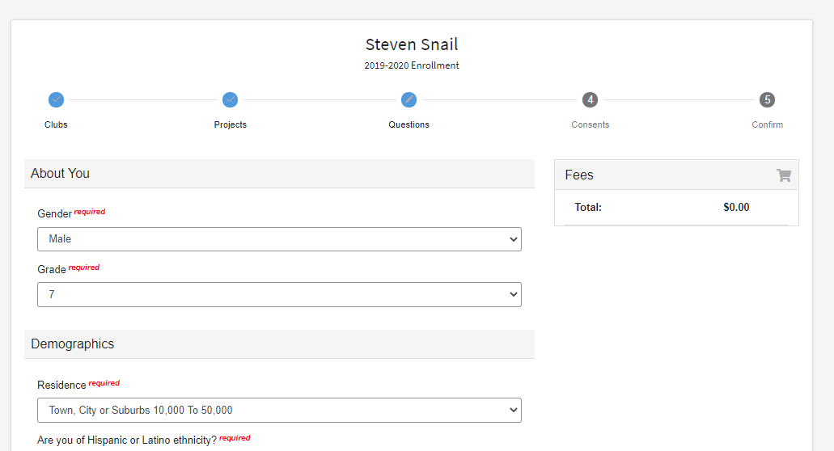
- Select the “Show Questions” button and complete the additional “About You” questions. Complete all of the required fields as indicated and click Next.

Step 6: Review and Sign Consent Forms
- Affirm that you agree to the Code of Conduct, the General Permission statement, and the Photo Release. Both the member and a parent/guardian names should be typed into the boxes and click on the agreement buttons.

Step 7: Review Enrollment
- Review your enrollment and select submit.
  - Remember, do not hit submit until you are sure that you have selected
all of your projects for this year.

You have now successfully submitted your enrollment.

Need to make changes?
- If you need to make changes before your enrollment is reviewed and accepted by county staff, you will need to contact your Extension Office to request a change.

Need to Enroll another new member?
- Select the blue “Add member” button at the top of your family profile and create a new member.

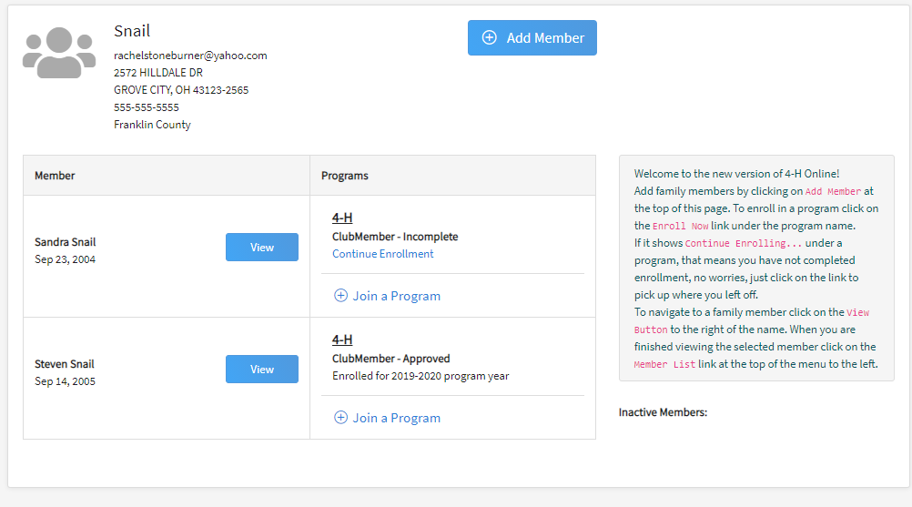

Any questions or if you are experiencing problems using 4HOnline:
- Call your local Extension Office

